学术讲座

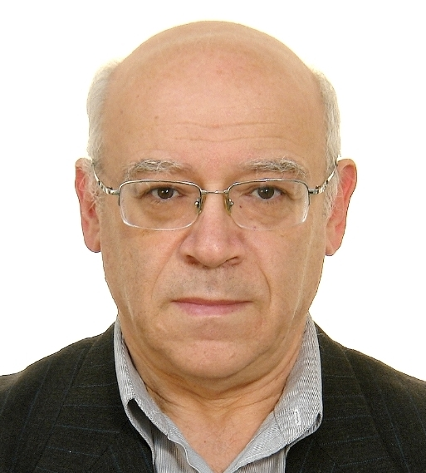
Abstract
In the lecture some review is presented of theoretical and experimental results for the fluctuations of sound signals crossing moving train of nonlinear internal waves (NIW). Typical length of an acoustic track is a few tens of km. It is shown that in dependence on angle between direction of an acoustic track and wave front of NIW we have different properties (parameters) of spatial and temporal fluctuations of sound signals measured by horizontal or/and vertical line arrays or single hydrophones. These different properties are provided by different mechanisms which are responsible for the sound fluctuations and depending on horizontal angle mentioned above: mode coupling, adiabatic variability and horizontal refraction. In the lecture all three mechanisms are analyzed and the corresponding experimental observations are submitted.

Biography
Boris G. Katsnelson is a Professor of Physics Department, Voronezh State University, Russia and the School of Marine Sciences, University of Haifa, Israel. He has done some excellent works on wave propagation theory, oceanography, underwater acoustics, acoustic tomography, and mathematical physics. He has hundred seventy publications including two books such as “Shallow water acoustics” and “Fundamentals of shallow water acoustics”. Recently, his research interests focus on sound propagation in three dimensional ocean environments.

时 间 | 题 目 | 地 点
2014年9月16日  上午9:00 | Horizontal Anysotropy of the Sound Fluctuations in the Presence of Moving Nonlinear Internal Waves in Shallow Water | 德昭楼南楼218会议室

中科院声学研究所 科技处
声场声信息国家重点实验室

